Crowdfunding a new project can be a tricky prospect. How can you tell whether or not a new idea will be likely to achieve funding? While it is not possible to determine the outcome of the future with absolute certainty, we can at least delve into trends from past crowdfunding campaigns to see what is likely to work.

Top Categories for Crowdfunding

To the right shows a chart of all the major categories available within this dataset. The first conclusion to draw from this is that by far, the most common avenue for a successful campaign is to support art, be it film & video, music, or theater. While these categories each have a large number of failed or canceled projects as well, they still represent the largest portion of campaigns to date.

However, the shear number of art projects alone do not indicate the *likelihood* of success with a project. This funding crown belongs to the technology sector, which boasts the highest ratio of successful projects overall, ignoring journalism (which doesn’t have enough datapoints to be significant).

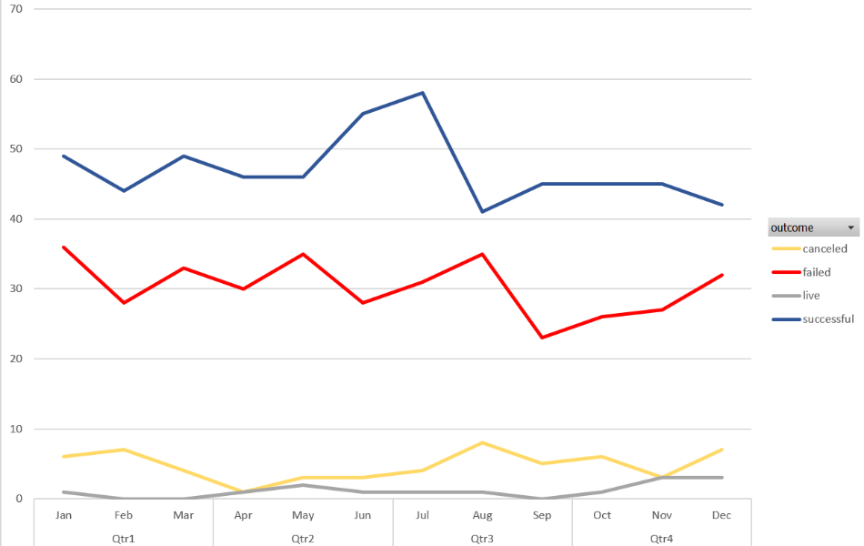When looking to crowdfund some sort of project, however, a group is unable to simply change its category just to attempt to source more capital; a new camera sensor can’t be categorized as a play just to attempt to grab more money. Since a new idea will have at least its major category set from its inception, what can be disserned that could give a project as much of an advantage as possible?

It appears that starting a campaign is June or July gives the biggest chance of success overall. This is based on failed campaigns showing a small dip during those months while successes reach their peaks. However, this may not be the case for every category listed. Next, I’ll explore how seasonal different categories tend to be.

Overall Trends by Month

Here, we can see that artistic funding is largely successful at most times of the year, with only a few months within each category showing any signs of higher failure than success at funding. Music seems to show the strongest correlation with seasonality of these, with a strong peak in July. Overall, these seem to be relatively good performers year-round. As we’ll see later, other categories have months with much weaker performance.

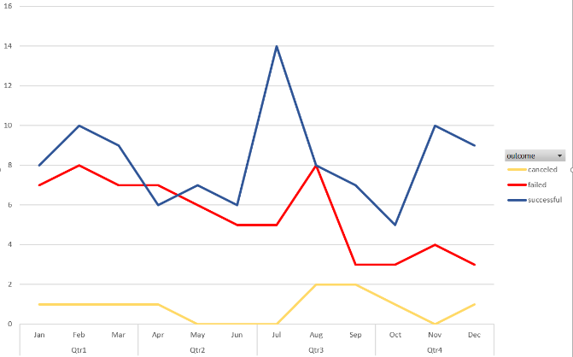

Music

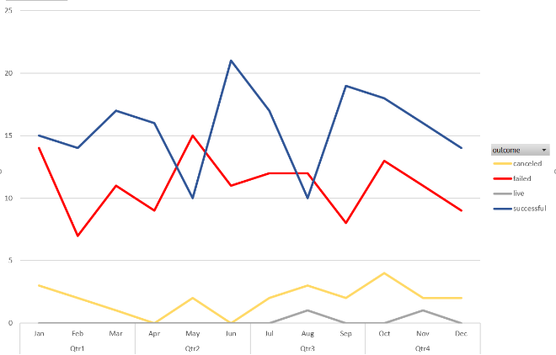

Theater

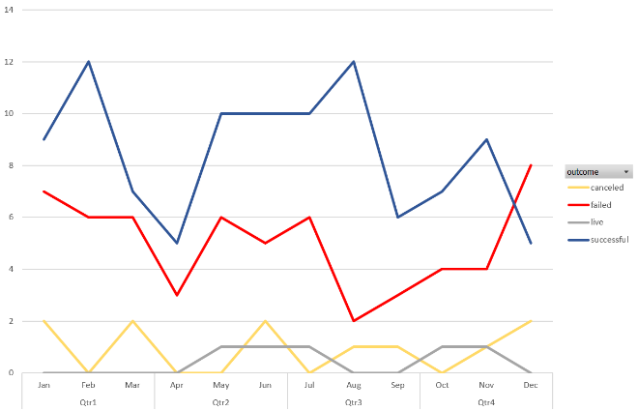

Film & Video

Technology, publishing, and photography tend to show stronger performance for the first two quarters of the year. It’s worth noting here that in this dataset, the technology category holds the sole distinction of typically having as many successful funding attempts as failures. Attempts to fund photography seem to fluctuate wildly from month to month.

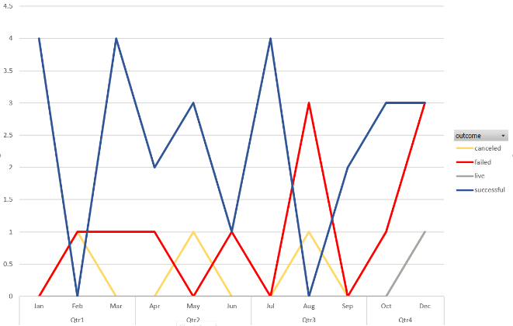

Figure Photography

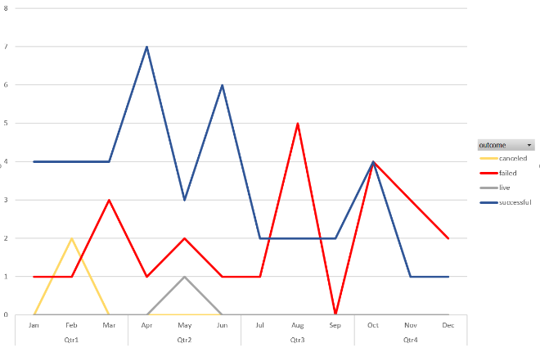

Figure Publishing

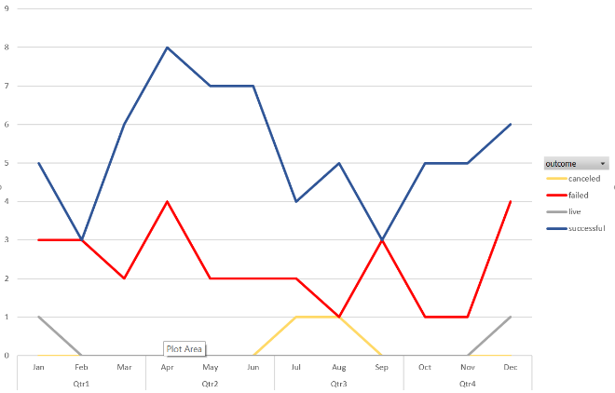

Figure Technology

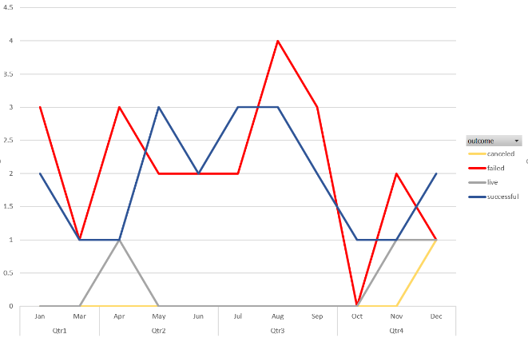

Games

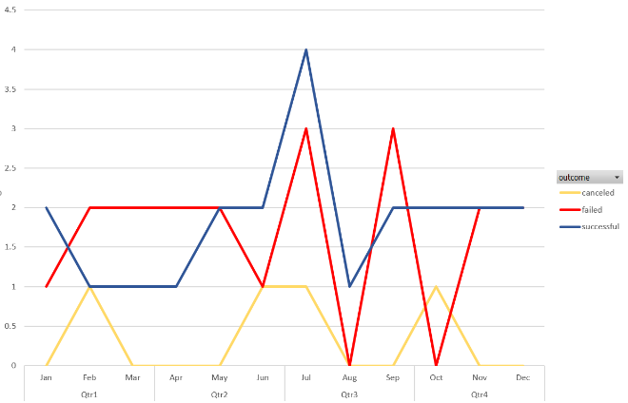

Food

The final two categories to consider, food and games, seem to be riskier than other choices. These two frequently fail more than succeed to gather enough funding to bring these projects to fruition.

This dataset could perhaps be improved by exploring more inputs. One thing that remains unknown is the effect of marketing on the success rate of different campaigns. This would include viral marketing attempts via social media, and advertising dollars. It would also be good to know if some of these campaigns stated any rewards for contributors.

One final bit of analysis for this dataset is as follows:

|  |  |  |
| --- | --- | --- |
|  | **Successful Campaigns** | **Failed Campaigns** |
| Mean backers | 851.15 | 585.62 |
| Median backers | 201.00 | 114.50 |
| Min backers | 16.00 | 0.00 |
| Max backers | 7295.00 | 6080.00 |
| Variance of backers | 1,603,373.73 | 921,574.68 |
| Std dev of backers | 1266.24 | 959.99 |

In this case, the relative difference in median helps to accentuate the difference between a successful campaign and a failed one more clearly than the mean does. There is significantly more variance in a successful crowdfunding campaign. The amount of money a person gives to such a campaign may vary upon both their own ability to afford charity and according to their own passion for the subject. This would make sense with artistic endeavors, as in some cases they are subject to either feast or famine. If a donor happens upon a subject they are passionate about, they may be more willing to part with larger sums of money.